BMW R1100RT & R1150 RT Mount Instructions

Upper Front | Upper Rear | Sub-frame
(1) 8mm-1.25x60 | (4) 6mm-1.0x25 | Left Side of Bike | Right Side of Bike
(1) 8mm flat washer | (4) Lock washer | (1) 12mm-1.75x40 | (1) 12mm-1.50x100
(1) 8mm nyloc |  | (1) 12mm flat washer | (2) 12mm flat washer
(1) 10mm-1.50x90 |  | (1) 12mm nyloc | (1) 12mm nyloc
(1) 10mm lock washer
(1) 10mm-1.50x260
(2) 10mm flat washer
(1) 10mm nyloc

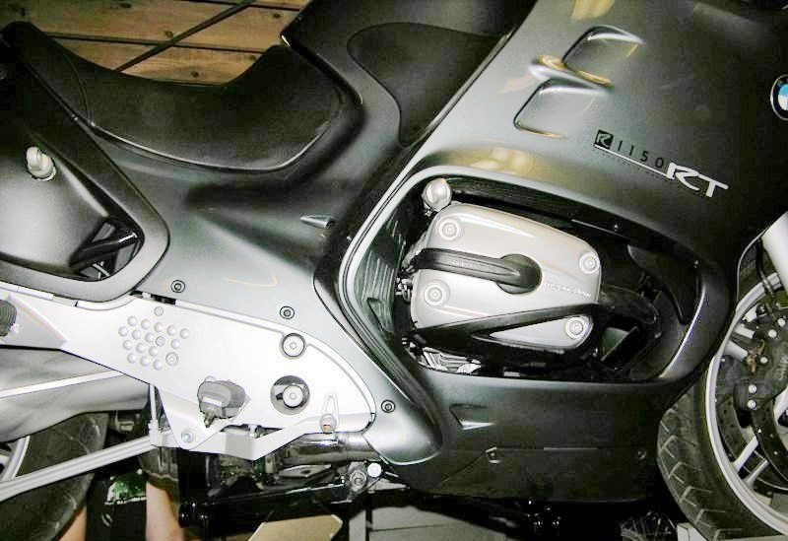
Over all View

BMW R1100RT & R1150 RT Mount Instructions

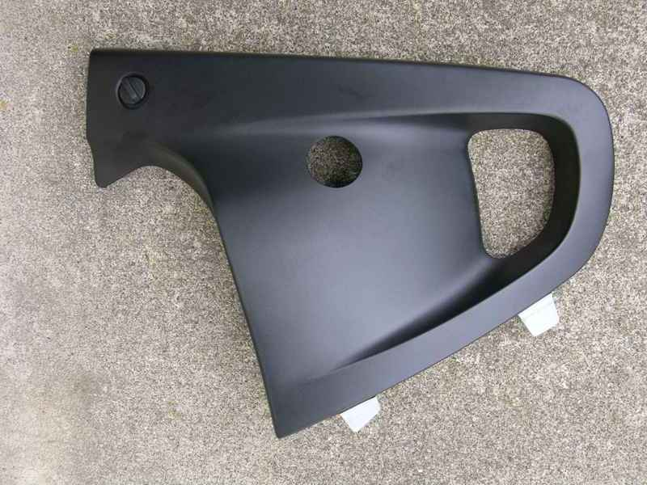 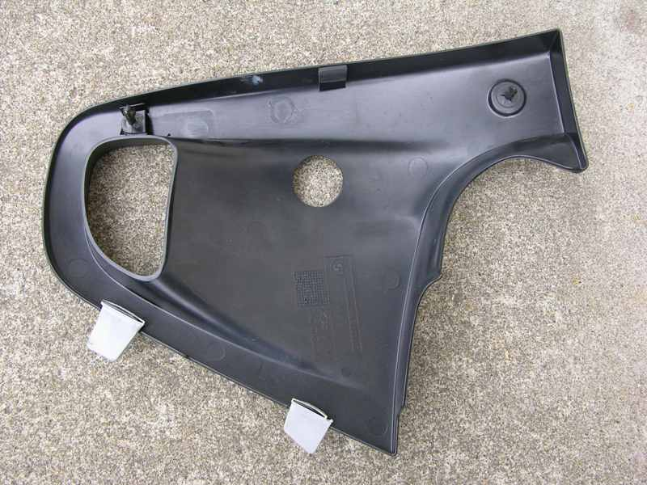
Panel with 1¼” hole cut out Inside View
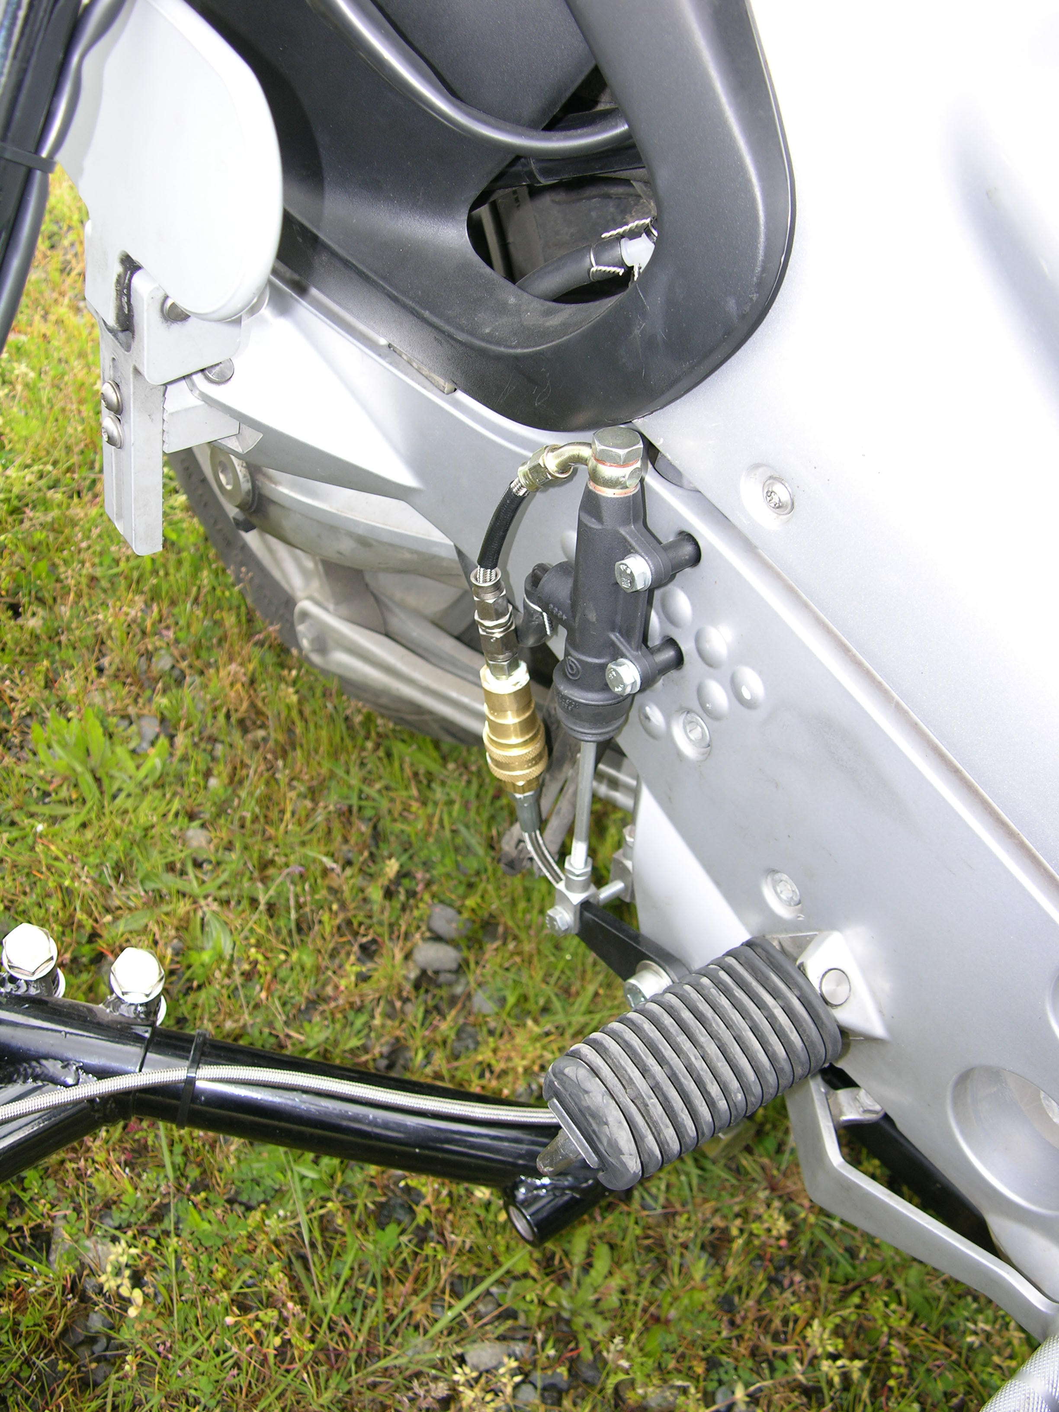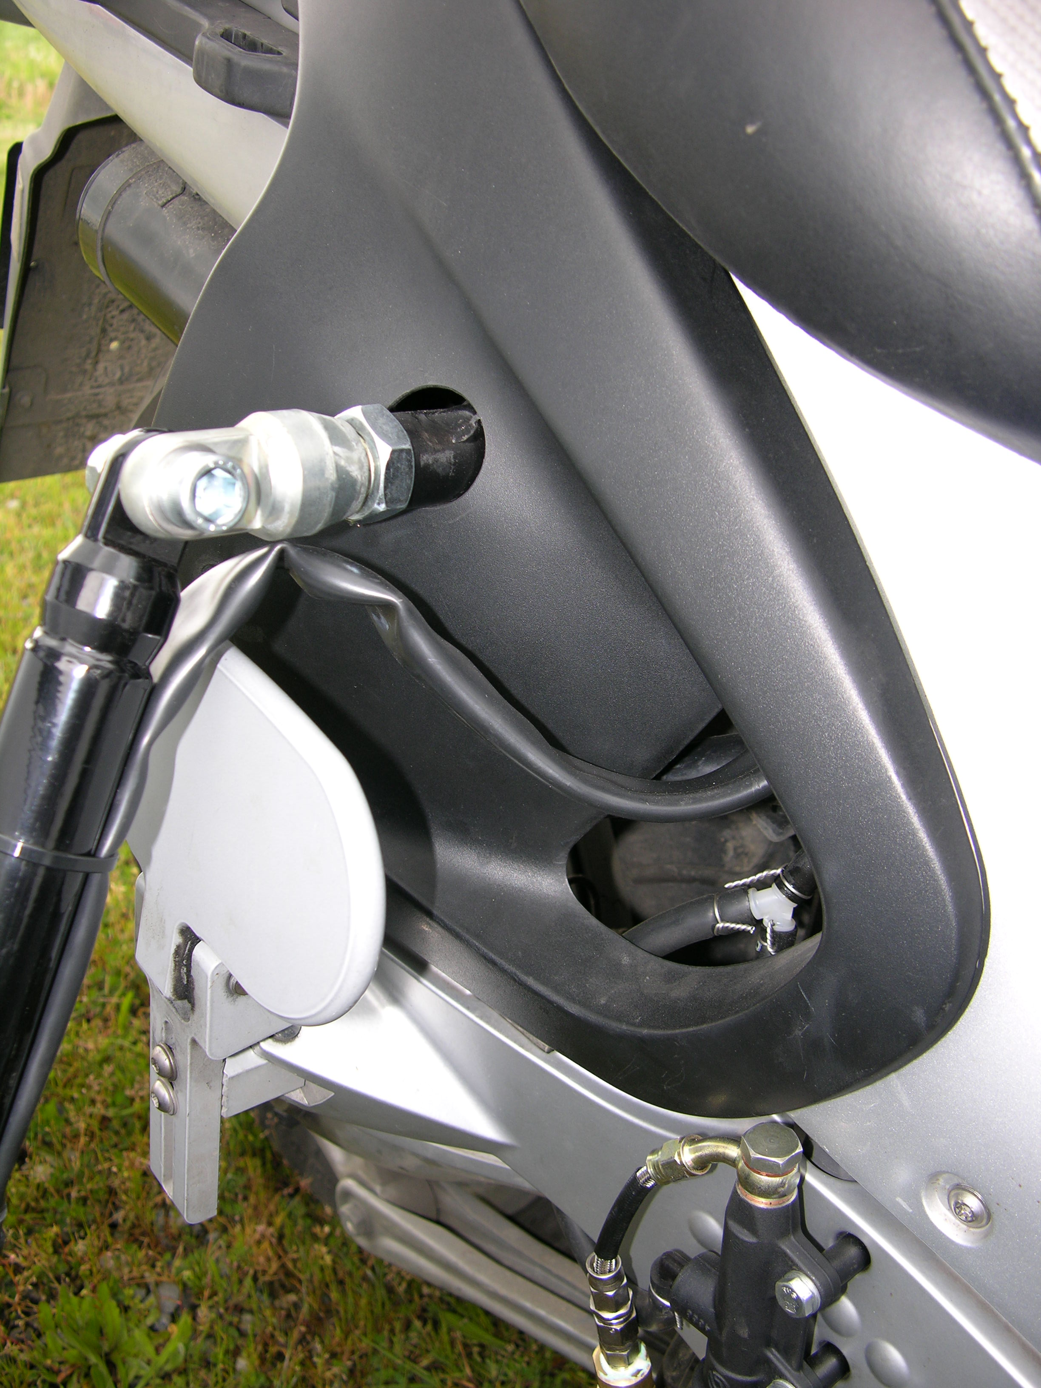
Brake Master Cylinder Location Upper Rear Mount with 1¼” Panel Hole

BMW R1100RT & R1150 RT Mount Instructions

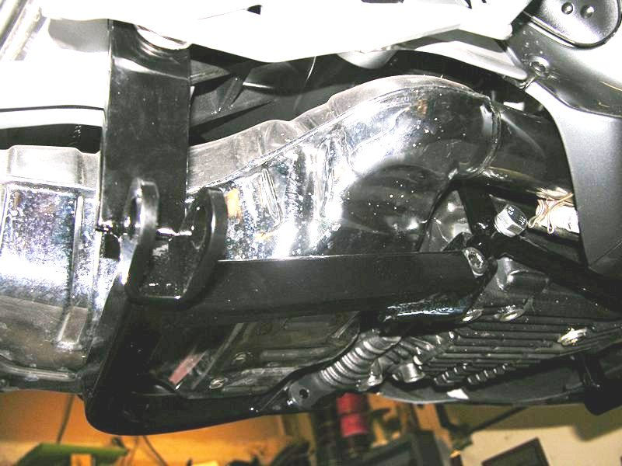
Lower Rear Mount

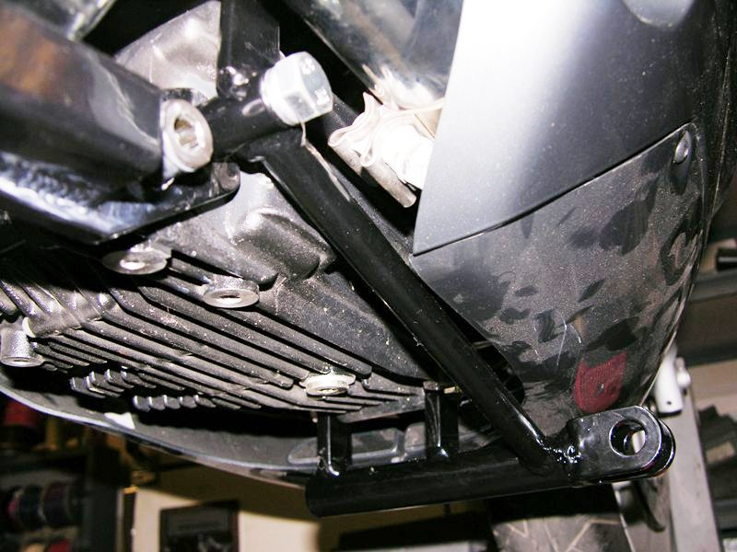
Lower Front Mount

